**heroes of pymoli data analysis**

**observed data trend 1:** Overall, players in the age group range 35-39 tended to spend the most, spending an average of $10.62 per player, a more than $3 per player increase over the next highest group.

**observed data trend 2:** There are far more male players making purchases than female purchasers. This more likely points to a larger trend of more males playing the game than females. Though the first point is shown to be true by our data, there is not enough information to show us the gender differences of game players overall. It would be interesting to compare the purchase data with overall data about the players.

**observed data trend 3:** Average total revenue per player was roughly $4 per player.

**Player Count**

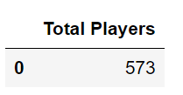

**Purchasing Analysis (Total)**

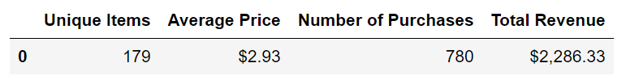

**Gender Demographics**

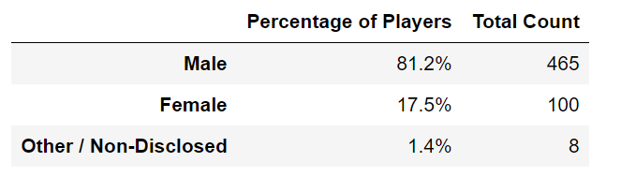

**Purchasing Analysis (Gender)**

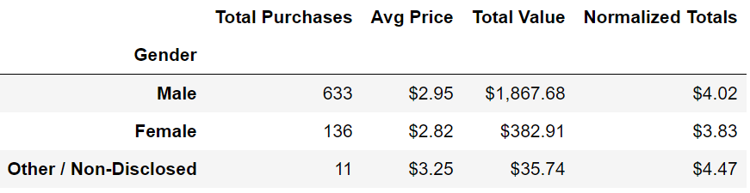

**Age Demographics**

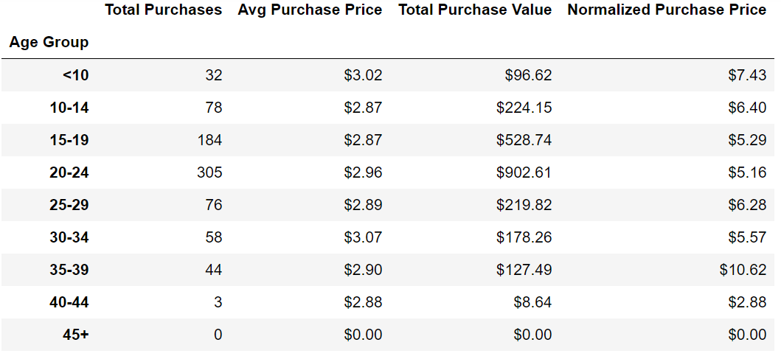

**Top Spenders**

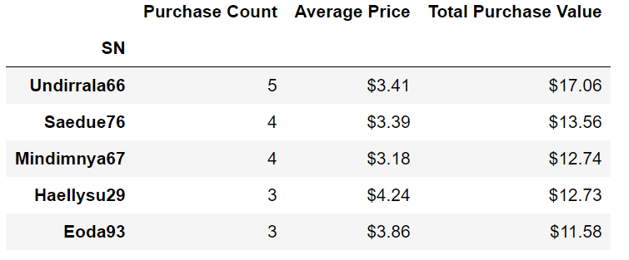

**Most Popular Items**

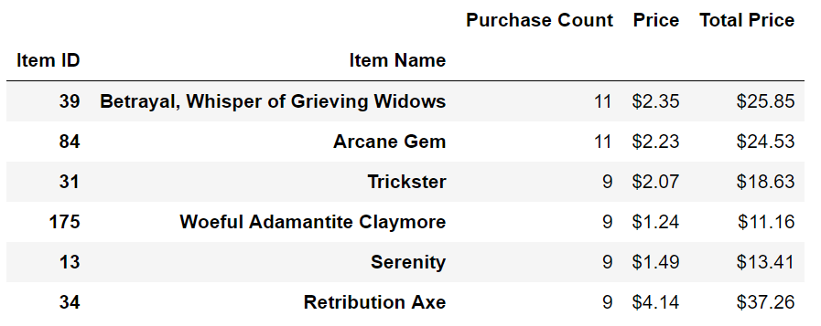

**Most Profitable Items**

